CP3405 Project – JCU Job Link

The following document is an anonymised version of a HD-level CP2408 project from 2017 that contains the various MVPs, user testing, personas and other Lean UX artifacts for a project called “JCU Job Link”. Use the information and ideas in this document as a starting point for your CP3405 project work.

# Problem Statement

Design Is a digital system implementation to enable users in the surrounding region to promote job opportunities, and students for these IT jobs. The system enables regional IT Employers, IT@JCU Students and IT@JCU Staff to effectively communicate by allowing:

* IT Employers to post IT job opportunities;
* IT@JCU Staff to recommend students as potential employees on particular IT roles; and
* IT@JCU Students to review and accept these IT job opportunities.

# Assumptions

* **Who are our customers?** Employers, Students/Employees, JCU Staff
* **When or how will our product be used?** On demand, Job seekers, when JCU staff recommend students, Employers looking to hire, digital website format
* **What Features will be most important?** On-demand feature (24/7 access), easily search and locate relevant students
* **What is our biggest product risk?** Competition, downtime (potential attacks) – network security risks, initial popularity, getting people on board, implementation

# Hypothesis statements

1. We believe that in providing an on-demand service for all of our users, this will in turn result in better user engagement within the web application. We will know this is correct when we see an increase in user activity and engagement via network traffic by 25%.
2. We believe that in providing a structured, easy to navigate website/app for all of our users will result in having a standout aesthetic that will see returning visitors. We will know this is correct when we see an increase in returning visitors by at least 25%.
3. We believe that in enabling students and employers to search/post job applications respectively will result in better user experiences for both aspects. We will know this is correct when we see an increase in search query responses by 25%.
4. We believe that in providing a communication platform for employers and students will produce a higher amount of communications and network activity on the web application/mobile app. We will know this is correct when we see an increase in network traffic by 40%.
5. We believe that in allowing IT@JCU staff to provide recommendations to employers concerning students will increase activity relevant to job application inquiries. We will know this is correct when we see job application request and offer activity increase by 30%.

**1st MVP: 10 Plus 10 Sketches:**

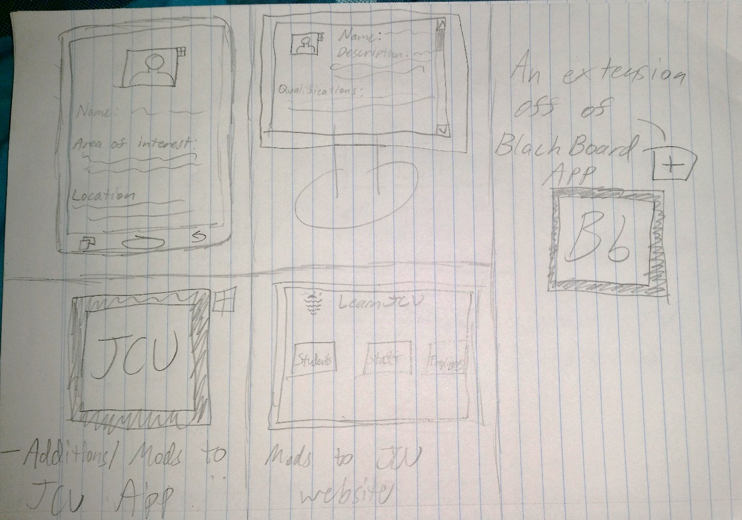

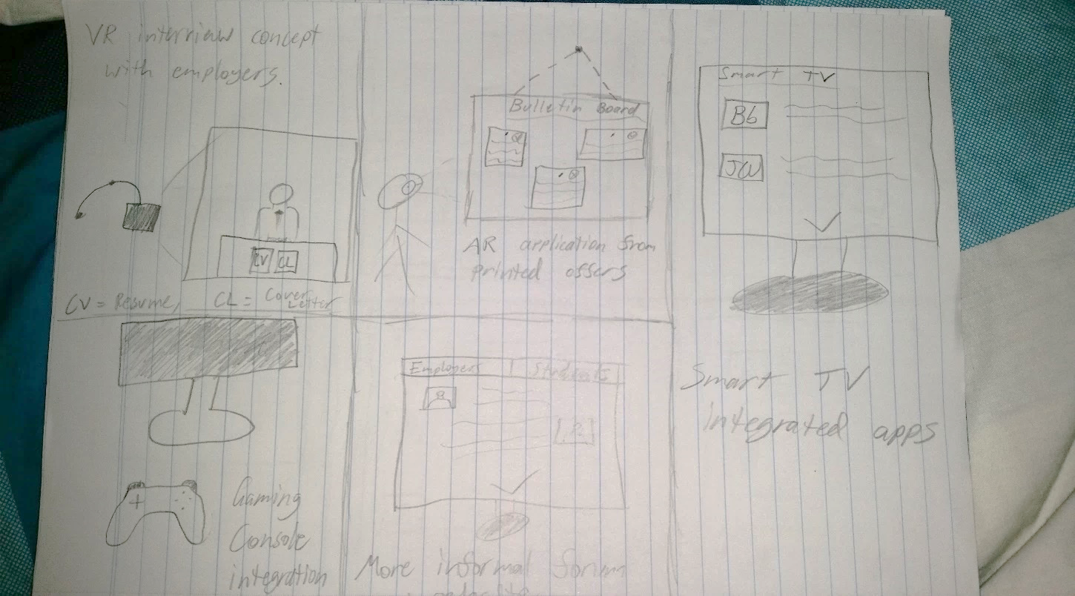

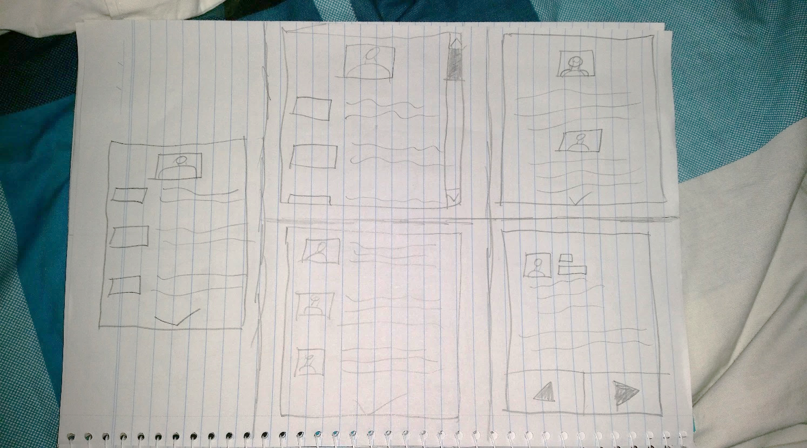

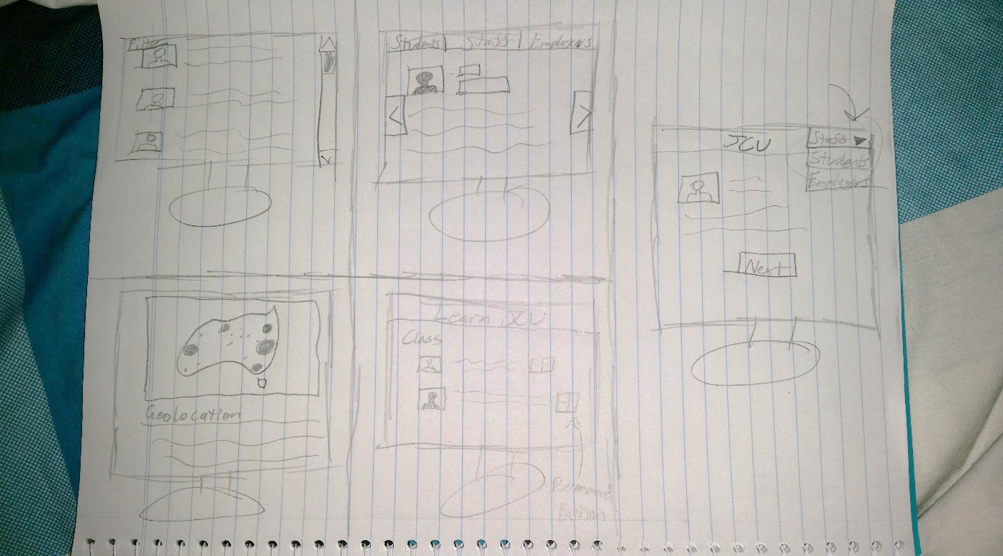

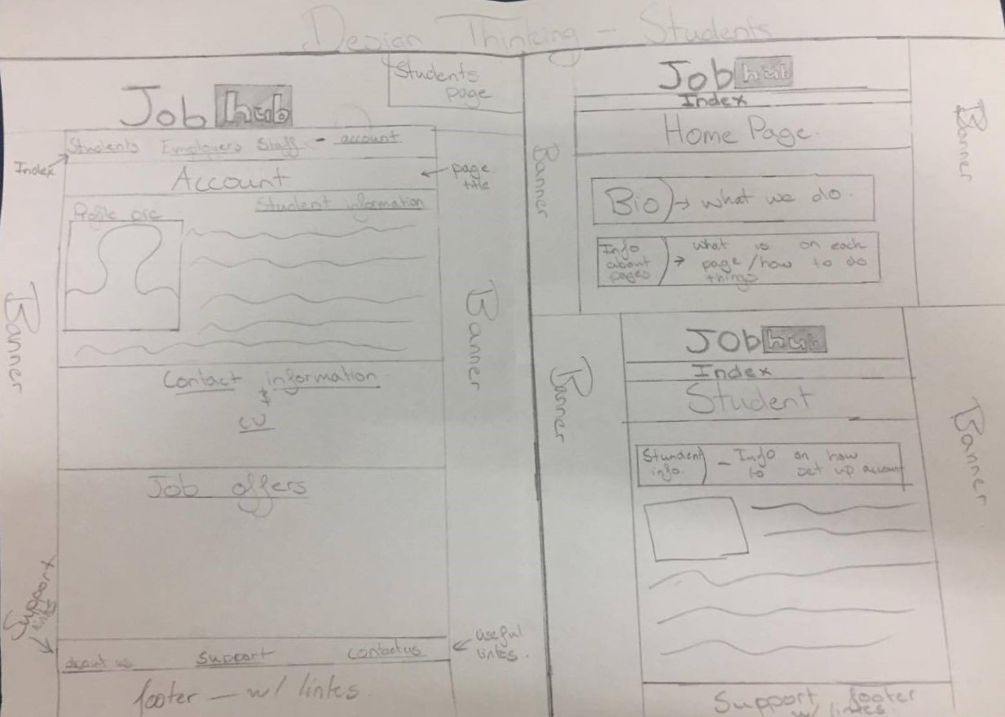

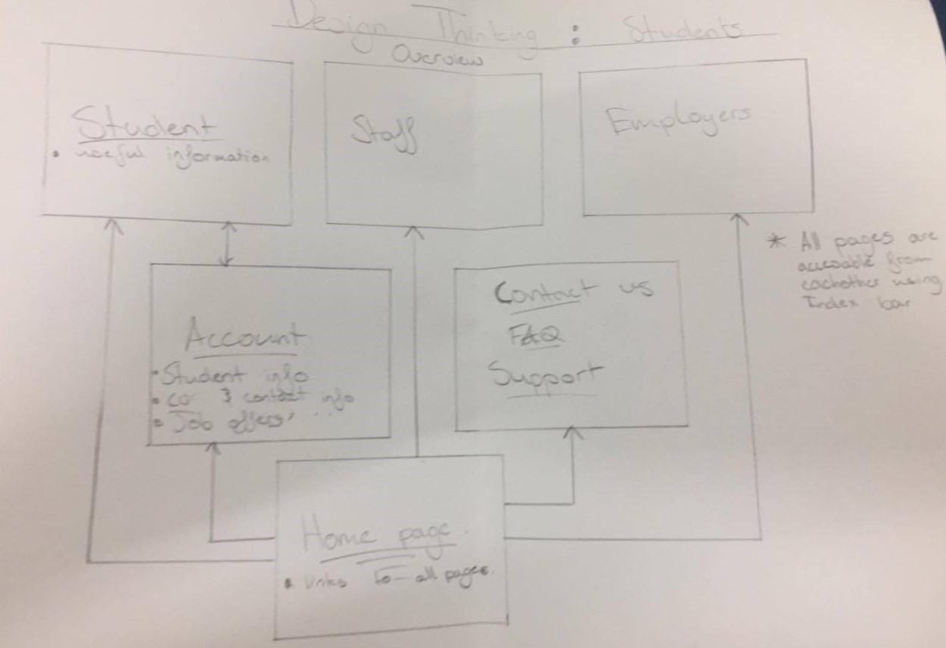

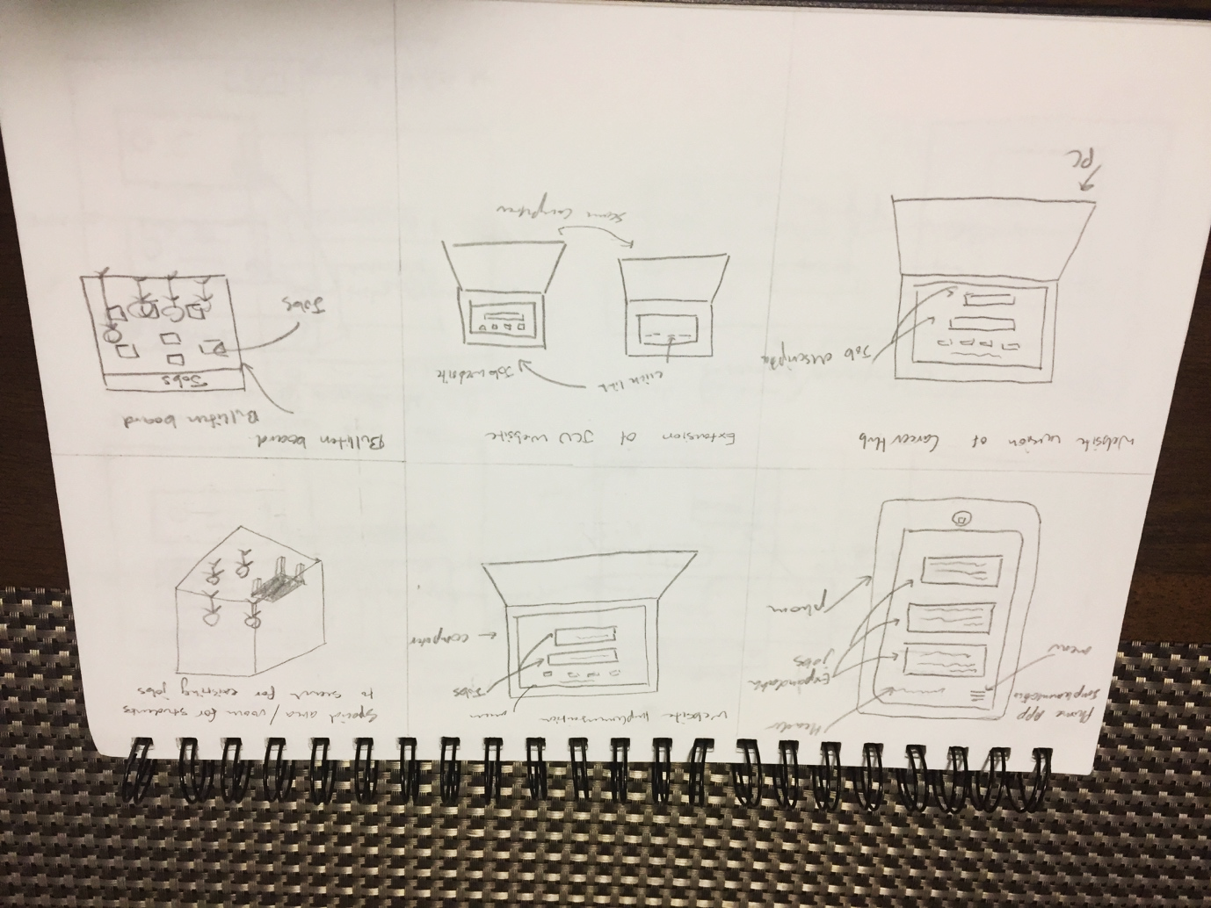

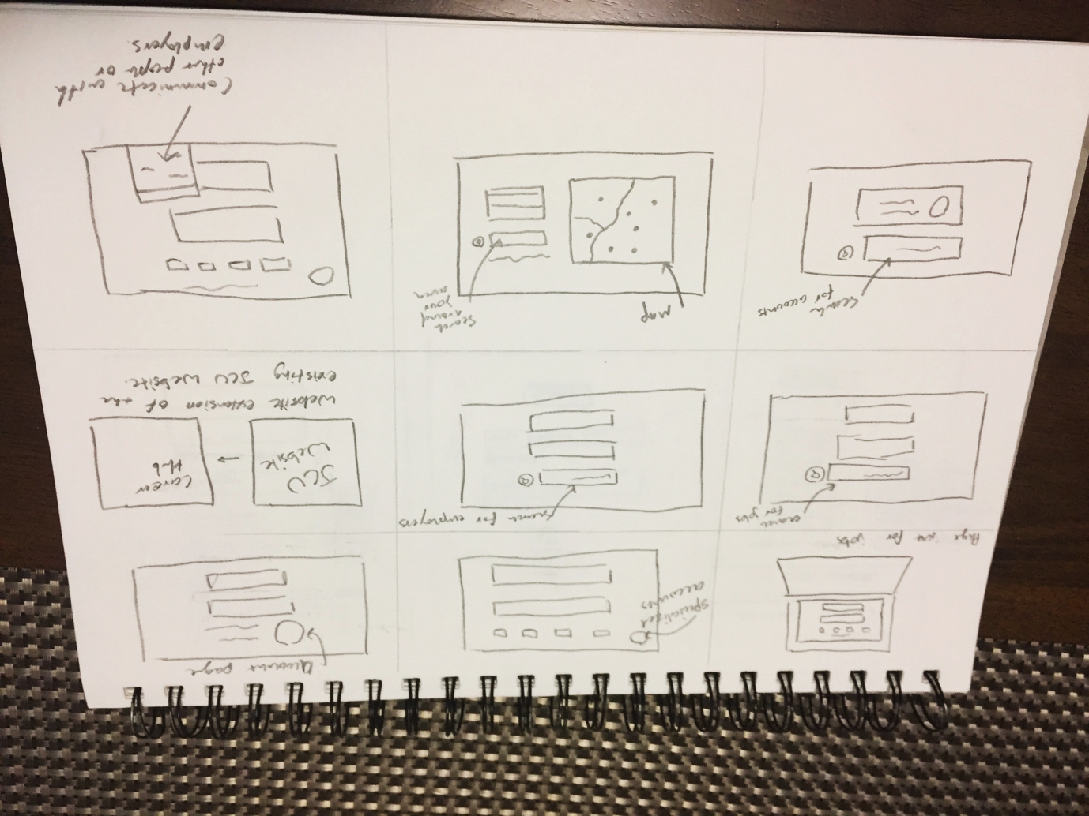

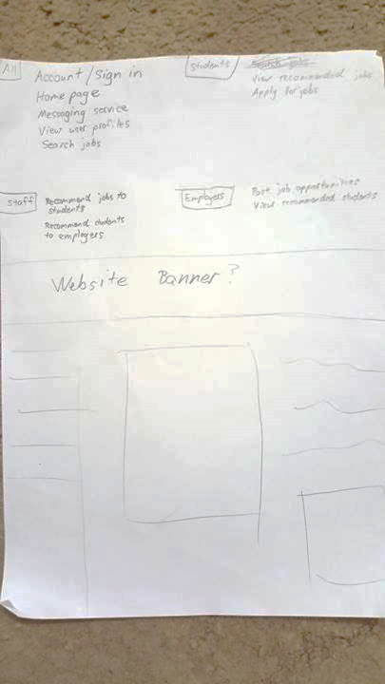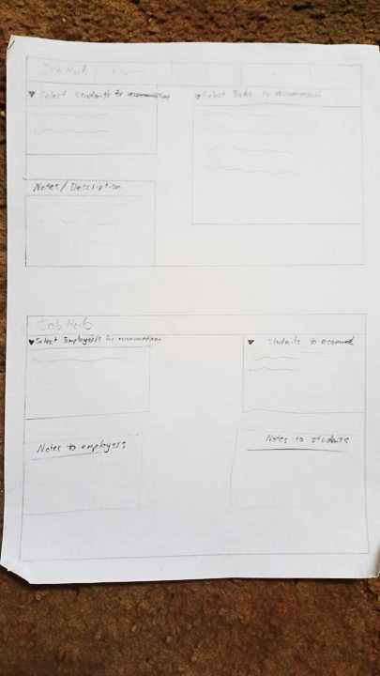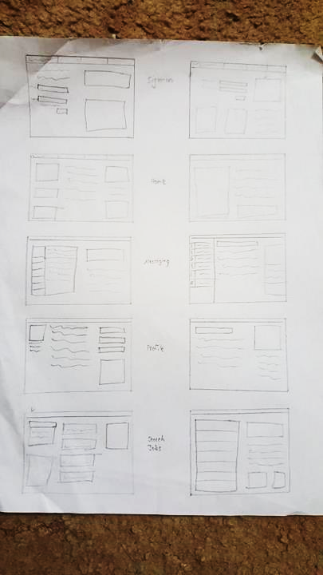

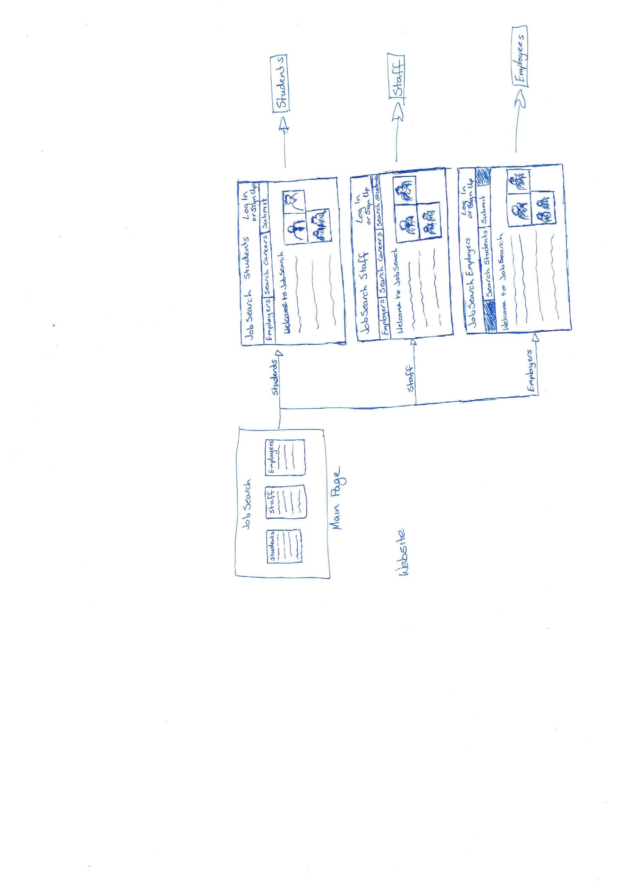

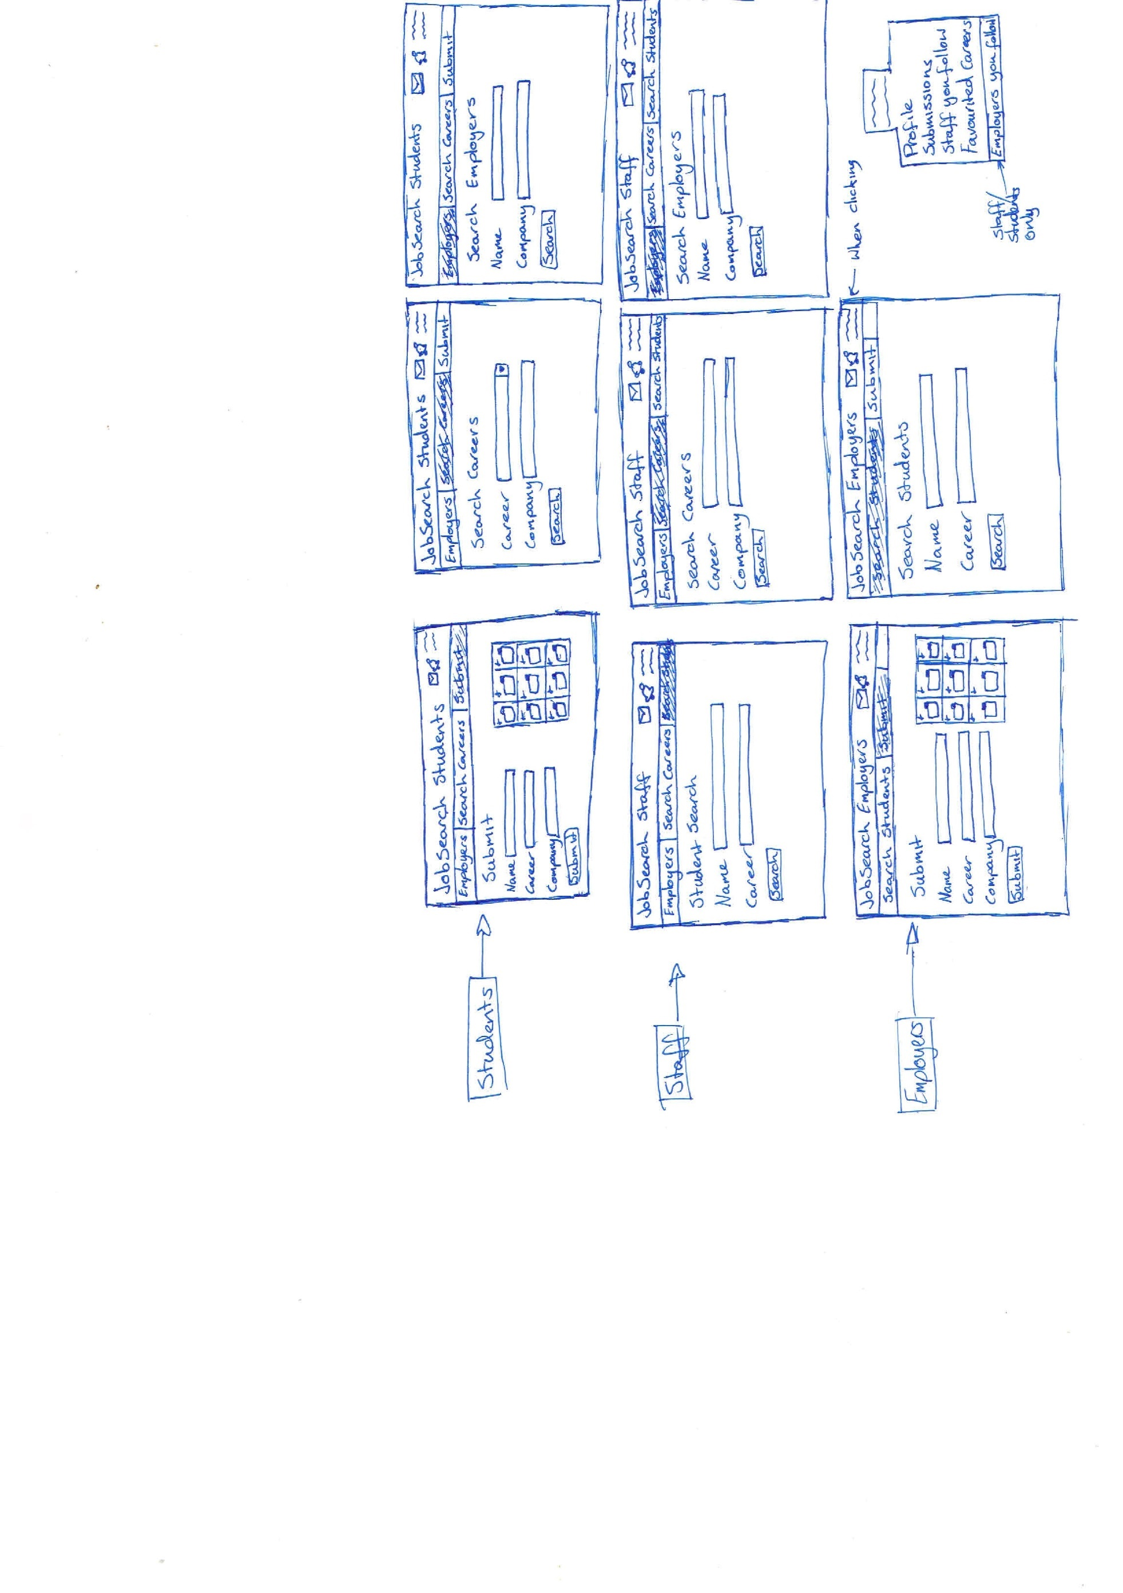

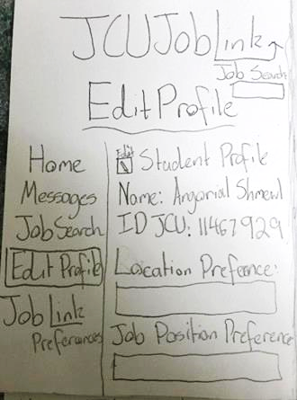

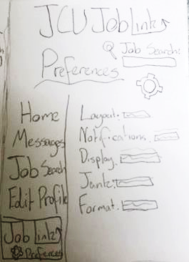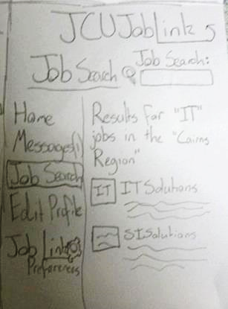

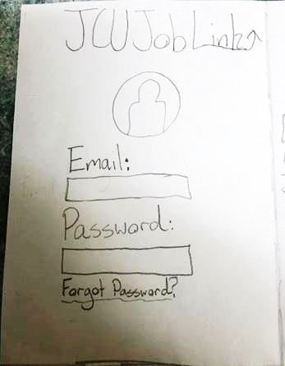

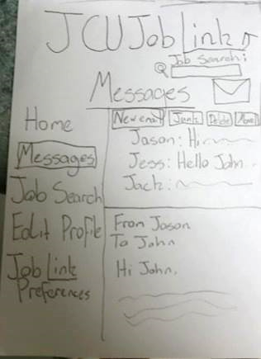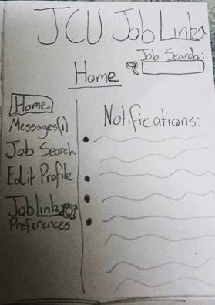

From these initial sketches, due to the quick and rapidly progressive nature of them, the team quickly sketched each of their ideas onto paper and chose an appropriate sketch to further elaborate upon, being a web application to be able to work on both desktops and mobile devices. Debated internally within the team, we decided this would be the best approach initially as at this stage, it would be barebones in displaying any sort of meaningful information about the prototype to the client.

**2nd MVP: Paper prototypes:**

**Iteration One:**

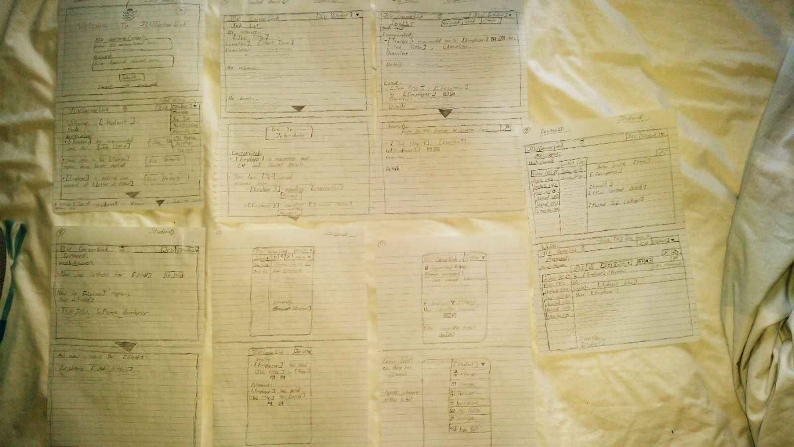

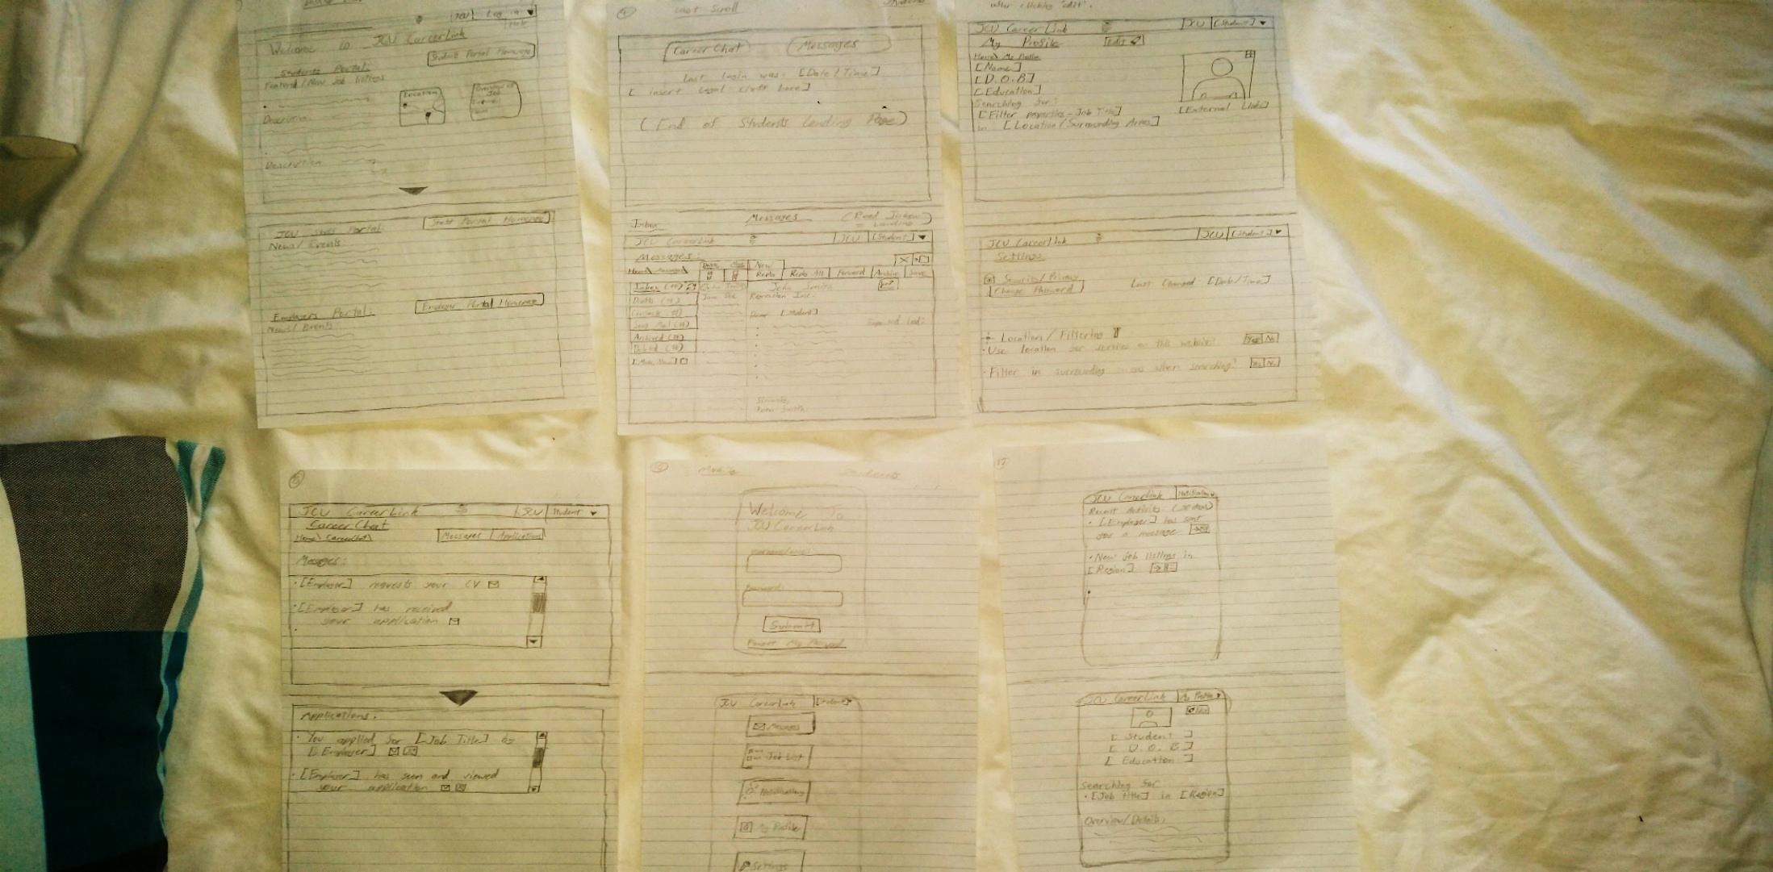

***Iteration Two:***

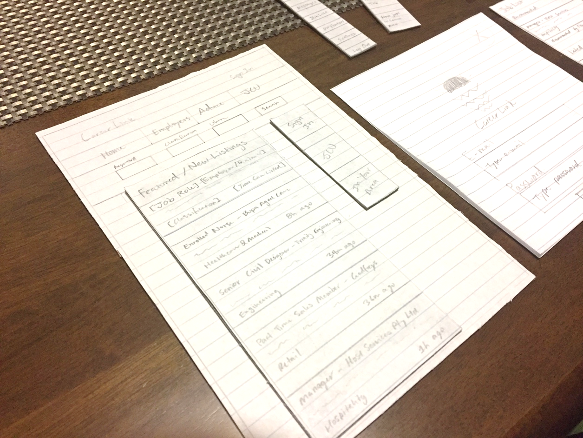

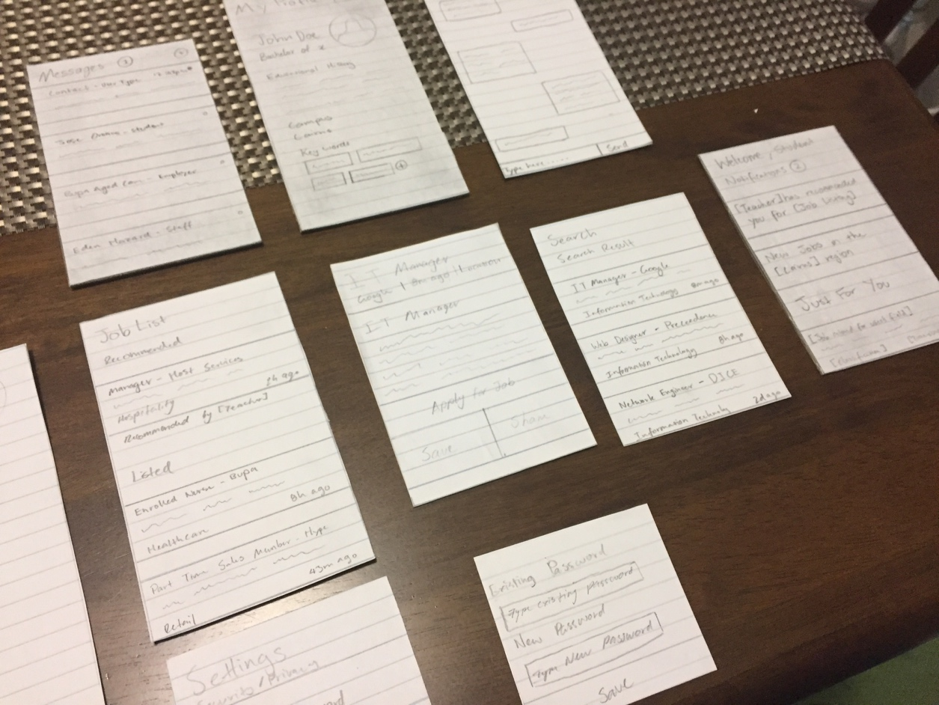

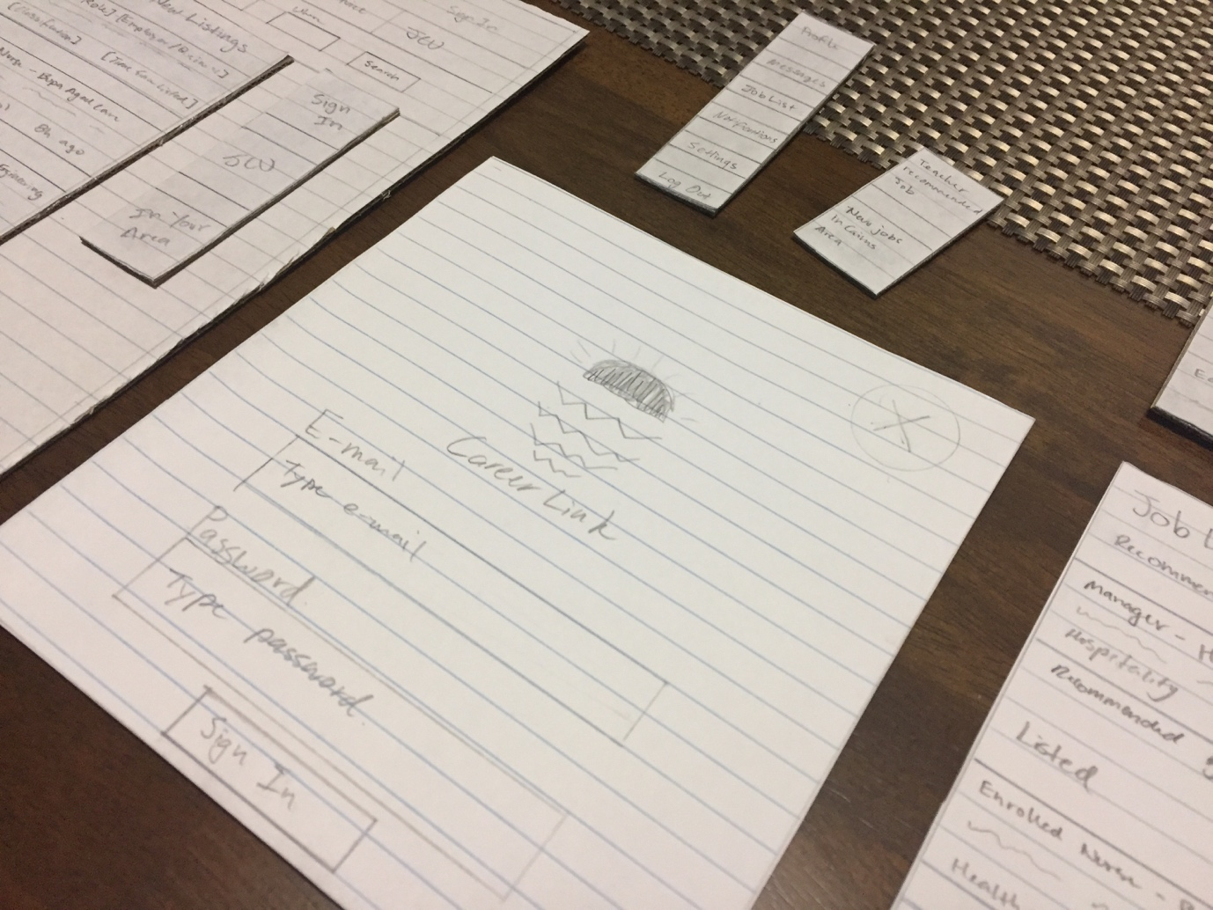

From these paper prototypes, with the 2nd iteration being presented to the user for the first user interview and test as some layout and functionality changes were necessary before presenting to the user to get a better idea of what to develop further upon. As a result, from testing, we got useful feedback from the client about which areas to improve upon such as naming conventions for certain buttons, layout aspects and other items mentioned in the testing portion of this report. Thus, from this information, a digital wireframe prototype was developed from the user’s feedback and current paper prototype as a basis for development in Balsamiq.

3rd MVP: Digital Prototypes:

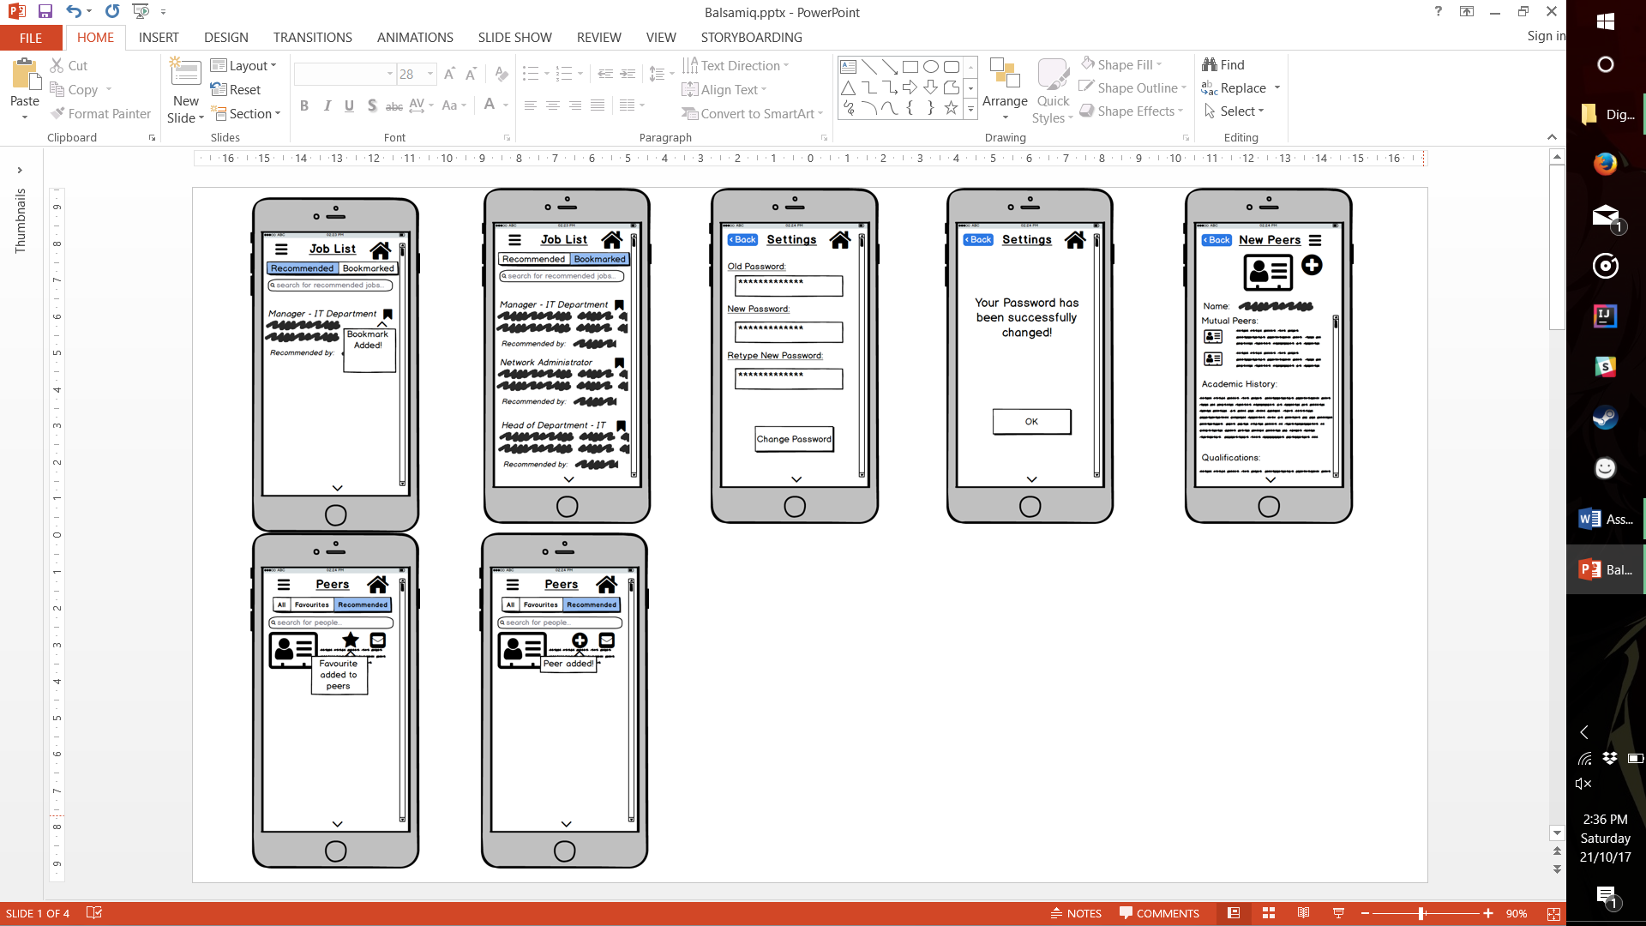

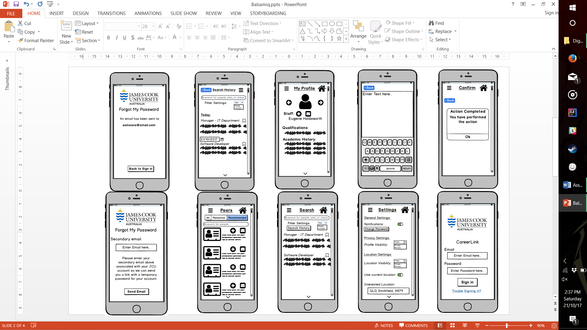

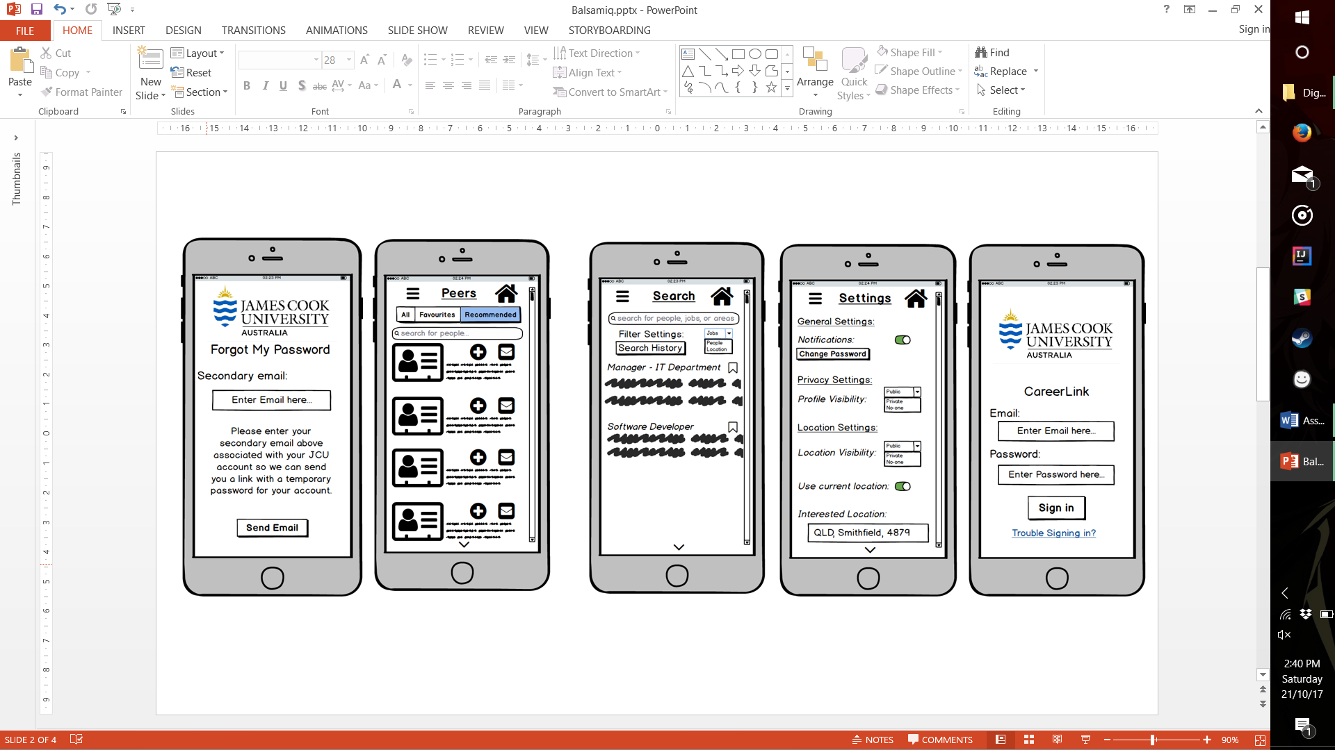

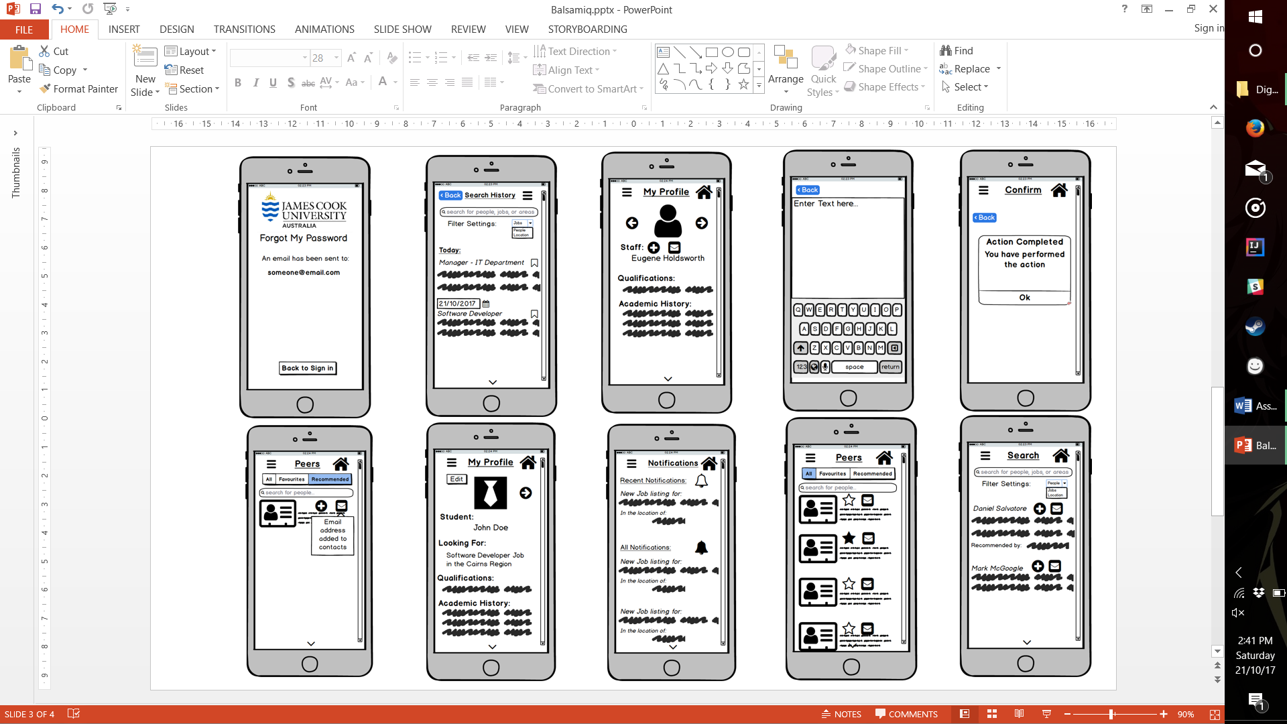

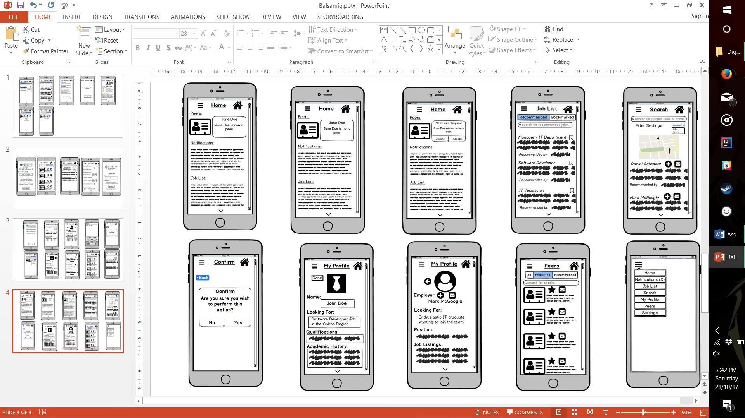

Developing in a digital environment posed its own challenges as this is the environment users are most likely going to the use the program in its further stages. As a result, limitations of the fixed sizes of mobile devices, readability on a small screen and clear form cohesion between each aspect of the potential application became a focal point for the team to develop for the different aspects of the digital program. Once each major aspect of the prototype was built, further dividing of each into subcategories of forms for different situations was implemented to make the digital prototype more robust and clearer in its objective to help establish communications between students and employers, with staff acting as intermediaries initially. Taking further inspiration from similar services from LinkedIn, and from our test of this version of the prototype, our attention shifted towards fine tuning the purpose of the application itself, which led to the idea of the following diagram:

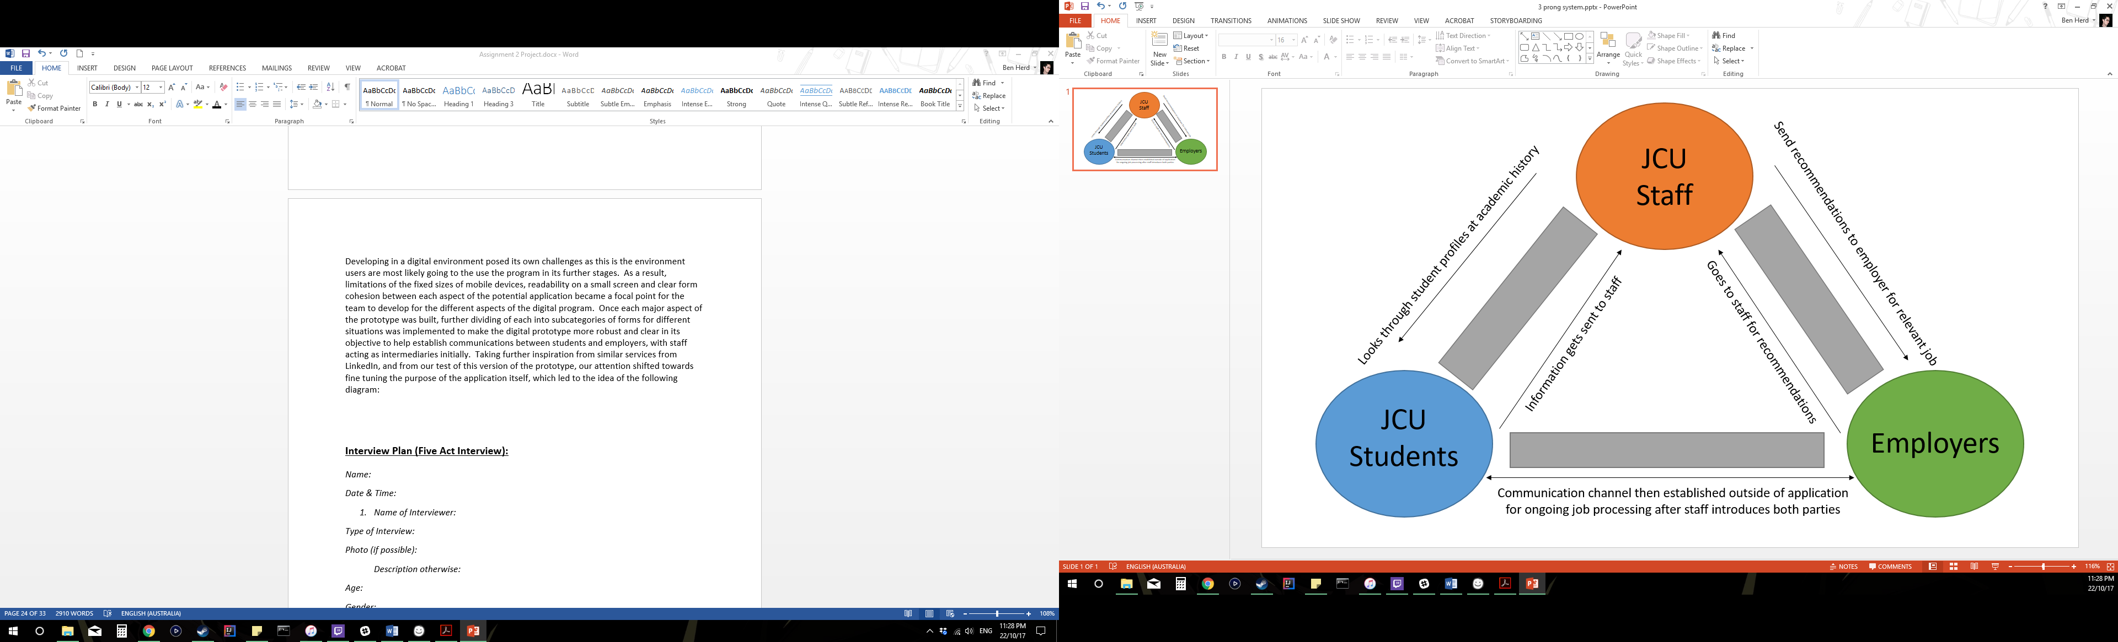

This diagram demonstrates how we need to develop further implementations of the prototypes in the future through encompassing the 3 aspects given to us in the brief of the project. A refocus of our efforts according to this shows that we need to remember that users are still most likely to use email or another digital messaging services that they are more comfortable with, thus, we need to accommodate such needs within our application. Also, the main objective for students and employers in this case is to establish a communication channel through the JCU staff members recommendations if necessary, in order to connect the correct students to the right employers looking for certain expertise or skills.

**This project consisted of team members with the following attributes:**

|  |
| --- |
| *Compromiser – Allowing each member to speak in an orderly fashion and bringing team discussion back on track to further development* |
| *Ideas Person – Generated unique ideas for use in prototype iterations and provided suggestions at each aspect* |
| *Leader – Organised meetings and assessment/assignment of tasks, and recollected all necessary information into submissions* |
| *Summariser – Brought ideas generated and made through each aspect and provided summary points for general overview of information gathered* |
| *Encourager/Recorder – In charge of recording interviews and monitoring team activity through each aspect* |
| *Encourager – Consistently urged members to have their say, gave changes and feedback* |